High Level Solution Options Change Pack

Communication Detail
Comm Reference: | 3383.1 – VO - PO
Comm Title: | XRN5924 - Physical Information Exchange (PIX) Ongoing Support Options
Comm Date: | 16/06/2025

Change Representation
Action Required: | For Representation
Close Out Date: | 30/06/2025

Change Detail
Xoserve Reference Number: | XRN5924
ChMC Constituency Impacted: | All ChMC Constituencies*  *All ChMC constituency members are required to vote on a preferred solution that will be implemented by the CDSP. Impacted parties on the Solution Options outlined below are primarily PIX Users only.  This could include organisations within any DSC Customer Class.
Change Owner: | uklink@xoserve.com
Background and Context: | As discussed at DSC Change Management Committee (ChMC) on Wednesday 11th June 2025, a revised Solution Option Change Pack is being issued out to include an additional solution option related to the PIX service offering.  This is following feedback received related to the Solution Option Change Pack issued in May 2025 (3373.4 – KL - PO) and aims to build on the risks, costs and impacts to organisations that remain on Physical IX (PIX) beyond the timescales proposed as part of the available solution options that have been put forward.  We encourage all customers of the IX service to provide representations to this Solution Option Change Pack and can clarify that approval of a preferred option is being sought in July 2025 ChMC from DSC ChMC voting members. All representations received (unless marked as confidential) will be presented and made public to aid decision making in line with DSC Change Management procedures.  The DSC ChMC voting members are asked to review the material related to these solution options and make appropriate determination on a preferred option for the benefit of their respective constituencies, inclusive of any organisations that are likely to remain on PIX beyond the dates proposed within the respective solution options.  For the avoidance of doubt, only those organisations that are likely to remain on PIX beyond the dates proposed by the respective solution option will be impacted by this change. All organisations that have successfully migrated to the Cloud IX (CIX) solution will not be directly impacted by this Change Proposal.  For additional context, please see attached the presentation that was discussion at ChMC on the 11 June 2025.

Solution Options
Solution Option Summary: | This revised Solution Option Change Pack considers two Solution Options for XRN5924 and the CDSP wishes to consult the industry and specifically PIX users on the proposals outlined below.  Solution Option High Level Comparison:  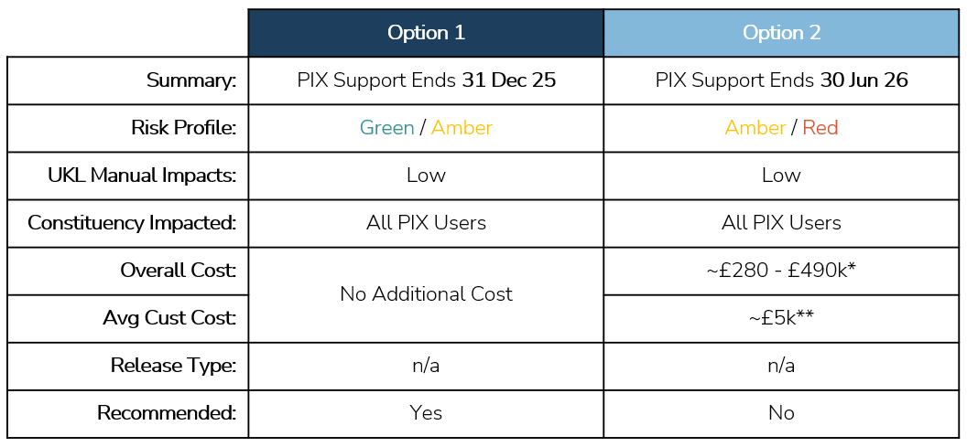  It should be noted that the only discernible difference between these two options is the date by which the CDSP will formally remove PIX support offering, and the costs associated with the difference in dates of this support ending. Once approved, the option will set an industry agreed deadline by which any remaining PIX users will need to migrate to CIX.  The risks related to providing PIX support (outlined below) are the same for both solution options, however they increase in severity and likelihood the longer PIX remain in situ. Please note that the below risks have only come to light recently as we engage the full supply chain regarding service offering options following the advice received from the Telecoms industry, and these have accelerated the timescales regarding our intentions for sunsetting PIX.  For transparency, the risks set out below may not be entirely isolated to PIX users. This is due to the IX service, as per the UK Link Manual, also facilitating Code Communication Type 2 (Business to Business B2B flows).  This may mean that any degradation to the PIX service could have consequential impacts on CIX users that send/receive B2B flows between respective organisations.  We encourage all IX users to feed into this consultation to ensure the approach for PIX support is assessed against the full IX estate.  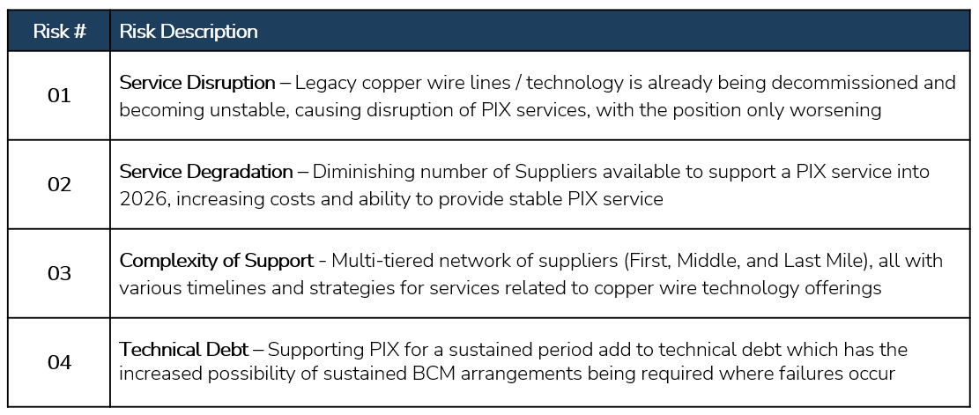  -------------------------------------------------------------------------------  Solution Option 1 – PIX Support Ends 31st December 25  Summary: This solution option is seeking to remove PIX offering to IX customers and set a formal date to migrate to CIX by the end of 2025. Please note, PIX is not provided to any new IX customers, new entrants to the market that required IX adopt CIX straight away.  Risks: The risks outlined above are present now as we are seeing a number of providers that support the PIX service deteriorate, this is currently manageable and has not yet had a detrimental impact on PIX performance or availability, but degradation is expected as we move through 2025.  Impacts: This proposal requires all PIX users to move over to CIX by the end of 2025 and the UK Link Manual to be updated to reflect the removal of PIX as a service offering by the CDSP.  Costs: There are no additional costs related to this proposal; all currently agreed costs associated to PIX customers via specific services remain.  -------------------------------------------------------------------------------  Solution Option 2 – PIX Support Ends 30th June 26  Summary: This solution option is seeking to remove PIX offering to IX customers and set a formal date to migrate to CIX by the end of June 2026. Please note, PIX is not provided to any new IX customers, new entrants to the market that required IX adopt CIX straight away.  Risks: The risks outlined above are expected to increase in severity and likelihood as we move into 2026 and the closer to the full PTSN switch off in early 2027. The end-to-end supplier network that underpins PIX and the telecoms infrastructure as a whole will be decommissioning throughout 2026 and as a result the CDSPs ability to provide a stable PIX service diminishes substantially. The CDSP has BCM arrangements in place, with IX services being included in this, however if invoked cannot be sustained for extended periods and therefore customers ability to transfer industry critical files as per the UK Link Manual could be severely hindered.  Impacts: This proposal requires all PIX users to move over to CIX by the end of June 2026 and the UK Link Manual to be updated to reflect the removal of PIX as a service offering by the CDSP.  Costs: There will be additional costs incurred with extending PIX support out to June 2026 and this will mean an increase to PIX service costs for those that remain on PIX. For the avoidance of doubt, costs outlined will be levied to those users on PIX as of 01 Jan 2026 and not socialised across CIX users or funded via DSC Change Budget.  Overall Costs: ~£280 - £490k  (This is dependent on the remaining PIX Customers as of 01 Jan 2026 (lower 50 / upper 100)  Avg Customer Costs: ~£5k  (Costs will increase per Customer depending on remaining PIX Customers as of 01 Jan 2026, avg value based off 100) / (costs for each user is also dependent on the existing set up, i.e. number of services, number of locations and connection types)  For clarity, any extension to PIX Support will be for a minimum of 12-month term, this means that any PIX user from the 01 Jan 2026 will, regardless of how long they remain on PIX into 2026, be charged for the full 12-month support costs, other wrap around PIX service costs will be rebaited to users, but this would be in the minority.  As per the [Background and Context] section, any costs incurred for the extension of PIX support past 2025 will be levied onto PIX users as of the 01 Jan 2026 and not socialised to CIX users or funded via the DSC Change Budget.  -------------------------------------------------------------------------------  Conclusion: As discussed at ChMC on the 11 June 2025, it is imperative that the CDSP has an agreed industry driven date in which to sunset the PIX service offering. The longer this date is the higher risk there is of service degradation which if experienced will have a knock-on impact to the industry (IX is also used for B2B file flows and not just CDSP DSC traffic). Our recommendation is to proceed with Solution Option 1 to mitigate risks detailed within this change pack but acknowledge that this may not be appropriate for some customers due to the timescales of which to migrate to CIX.
Proposed Implementation Date: | 31st December 2025
Xoserve preferred option:  (including rationale) | Solution Option 1
DSG preferred solution option:  (including rationale) | n/a

Service Lines and Funding
Service Line(s) Impacted - New or existing | Propose to remove the following:  SS-SA22-18: Provision installation and maintenance of an Option 1 IX connection.  SS-SA22-19: Provision installation and maintenance of an Option 2 IX connection.  SS-SA22-20: Provision installation and maintenance of an Option 3 IX connection.  SS-SA22-75: Provision, installation and maintenance of an Option 4 IX connection.  SS-SA22-21: IX additional service - external relocation.  SS-SA22-22: IX additional service - internal relocation.  SS-SA22-23: IX additional service - remote configuration.  SS-SA22-24: IX additional service - services outside of Business Day  Propose to amend the following:  SS-SA22-25: IX decommission  SS-SA22-76: IX service via a User Agent
Level of Impact | Low
Impacts on UK Link Manual/ Data Permissions Matrix | The UK Link Manual suite of documents will need to be amended to reflect the agreed proposal. These will be drafted and communicated out to DSC once a Solution Option has been approved at ChMC.

Industry Response Solution Options Review
Please consider any commercial impacts to your organisation that Xoserve need to be aware of when formulating your response
Organisation’s preferred solution option
User Contact Details: | Organisation: | E.ON
 | Name: | Andrew Eisenberg
 | Email: | andrew.eisenberg@eonnext.com
 | Telephone: | 07890555151
Organisation’s preferred solution option, including rationale taking into account costs, risks, resource etc: | We prefer and approve solution option 2.  Considering the lack of notice parties have had regarding the potential vendor risks and Xoserve's preference to withdraw PIX support in December 2025, current PIX users must have this contingency time to ensure smooth changeover to the CIX solution.  Only those who remain on PIX past December 2025 will be impacted by the increased costIt is therefore fair on all parties, including those who have already moved to CIX or will do so by December 2025.  In regard to risks of degradation of service, these risks exist regardless. The only difference being a removal of support for those who are unable to meet a December 2025 switch to CIX (due to the lack of timely notice given by Xoserve). Such removal of support would only make the potential of loss of service to those parties more likely or more severe.  A backstop which significantly mitigates these risks for parties who cannot meet December 2025, at a cost only to those parties, is preferable to a rug-pull.
Commercial impacts: | See above.
Customer decision on preferred solution option: | approved
Publication of consultation response: | N/A
Xoserve’ s Response
Xoserve Response to Organisations Comments: | Thank you for your response, this will be discussed at ChMC in July

