Detailed Design Change Pack

Communication detail
Comm Reference: | 3425.1 - VO - KG
Comm Title: | XRN 5732 - Inclusion of IGT MPRNs into specified existing DSC Processes
Comm Date: | 13/10/2025

Change Representation
Action Required: | For Representation
Close Out Date: | 27/10/25

Change Detail
Xoserve reference Number: | XRN 5732
Change Class: | Functional Change
*ChMC Constituency Impacted | IGT  Shipper
Change Owner: | uklinkdelivery@xoserve.com
Background and Context: | Existing DSC processes which cover arrangements introduced under UNC Modifications (MOD) 0424, 0425, MOD455, MOD410, MOD410A and MOD 0431/641s processes, in addition to related services provided to Distribution Network customers to facilitate GS(I&U) R (Gas Safety Register) obligations, were not included within the scope of IGT039 (Use of a Single Gas Transporter Agency for the common services, systems and processes) required by the IGT (Independent Gas Transporter) UNC (Uniform Network Code), and UNC Modification 0440 - Project Nexus – IGT Single Service Provision, respectively.  Following implementation of the above Modifications there has therefore been a disparity in treatment and services afforded to IGT Supply Meter Points.  It has become increasingly apparent that benefits could be achieved for Shippers and IGTs if these services can be mutualised and disparity in the treatment of IGT Supply Meter Points can be removed from the related processes.  The scope of this change includes ‘MUS’ and ‘GSR’ processes for the IGTs related to the MOD424, MOD425, MOD455, MOD410/410A and MOD 0431/641s and any associated processes and reports related to these above MODs currently undertaken under DSC contract for GTs (Gas Transporters) to be extended ‘As Is’ for the IGTs (Independent Gas Transporters).  By implementing this process, benefits could be achieved for Shippers, IGTs and CDSP. To ensure IGT customers have an equivalent level of interaction and involvement in the DSC specified processes where necessary, to enable mutualised service coverage across DN and IGT customers.

Change Impact Assessment Dashboard
Functional: | MUS (Manage Unregistered Sites) process  GSR (Gas Safety Register) process  Reports
Non-Functional: | Performance  Transaction Volume  Frequency  SLA and response time (as per BAU)  Data archival  Data security  Data availability
Application: | SAP ISU  SAP BW/ BO  SAP PO  CMS  UK Link Portal  GES Application
User(s): | IGT  Shipper
Other: | N/A

Files
File | Parent Record | Record | Data Attribute | Hierarchy or Format Agreed
N/A | N/A | N/A | N/A | N/A

Change Design Description
As part of change XRN5732, the IGTs (Independent Gas Transporters) will be able to run the GSR (Gas Safety Register), and MUS (Manage Unregistered Site) process and reports in line with those which are currently performed by GTs (Gas Transporters).

Manage Unregistered Sites (MUS) Process
The MUS process facilitates the identification of the responsible Shipper for every Supply Meter Point created on UK Link that has reached the anniversary of its creation date, remains unregistered and has a Meter point status of ‘Live’. Once identified the contact is monitored until the Supply Meter Point is registered and a meter attached within UK Link systems.

When the responsible Shipper has been identified, an MUS contact is referred to that Shipper to initiate the registration process and attach a meter. The contact facilitates the monitoring of the registration process and progresses the record through to the billing process where necessary. The Shipper can undertake the following actions when the contact has been referred:

- Confirm the Meter Point Reference Number into their ownership and attach the asset, or;
- Dispute the contact with justification

Where the Shipper disputes that they are the responsible Shipper, the CDSP and/or the IGT (Independent Gas Transporters) will investigate the reasons given and may uphold or reject the dispute. Where upheld, the CDSP (Central Data Services Provider) may identify another Shipper and refer to that organisation instead. If the dispute is not upheld the contact will be referred to the original Shipper to resolve.

Where the Shipper has not had a dispute upheld or has not actioned the confirmation of the Supply meter point within 30 business days, the CDSP will action the confirmation on the Shipper’s behalf. The contact will then be referred to the Shipper to attach the meter. Once the meter has been attached on UK Link the transportation charges for the unconfirmed period will be invoiced. All and any updates that are made in the IGT meter point will be reflected in the IGT delta and Quarterly refresh files (.IDL / .IQL file)

Detailed process overview related to MUS contact is described within the training material available on Xoserve’s website – which can be found here

*note the above training material will be updated to include IGTs as a listed stakeholder in the process.

GAS Safety Register (GSR) Process
Following the removal of a meter on UK Link by a Registered Shipper, in line with Gas Safety obligations, IGTs are required to perform investigations 12 months after the meter removal date to conclude where a service is still live at the property, with a meter attached and where the site is still capable of flowing gas.

To understand the position of IGT portfolio, IGTs will receive the ‘MOD518 report’ [report details attached for reference in the SAP BO/BW report section below] from CDSP via email and will be able to pull the .GSR file via the UK Link Portal. As part of this change, if any new IGT users need to be provided access to the UK Link Portal this will be arranged and follow the standard access control process in place.

Gas Safety Register file format

Where IGT investigations confirm that the site is still live, IGTs will be able to raise GSR contacts via CMS. This contact facilitates the re-establishment of Supply Meter Points to ensure Supply Point Registration and recovery of relevant charges is achieved where gas is consumed at a Supply Meter Point.

On the submission of the GSR contact by IGTs via CMS, validations will take place in CMS which will result in the categorisation of the GSR contact and the identification of the responsible Shipper.

The contact will be pushed to the responsible Shipper to carry out the activities of registering the Supply Meter Point into their ownership and/or attaching the meter on UK Link via the RGMA process.

The categorisation of the contact will determine the length of time the Shipper has to carry out the activities before the CDSP is responsible with carrying out the activity on their behalf.

In some instances, the CDSP will immediately attach the meter details on the Shipper’s behalf, and in some instances the attaching of the meter details may only be actioned by the Shipper.

In all but one instance, the Shipper can dispute that they are the responsible Shipper and the CDSP may uphold or reject the dispute. If the dispute is upheld the contact may be referred the IGT for further information or guidance, the CDSP may identify a different Shipper and push to their work queue, or the contact may be resolved immediately as invalid. In instances where either the CDSP or the IGT do not uphold the dispute, the contact will be pushed back to the responsible Shipper, and they will have the remainder of the time allocated for completing their actions.
Only once the Supply Meter Point is registered and relevant meter details attached will the contact be resolved as valid.

Where the meter identified as in situ by the IGT is the same meter that was removed from UK Link, then transportation charges will be triggered on the valid resolution of the contact.

IGTs will be able to raise GSR contacts via CMS Single User Interface screen or GSR Bulk Contact Logging (.NEI) file via User Interface below.

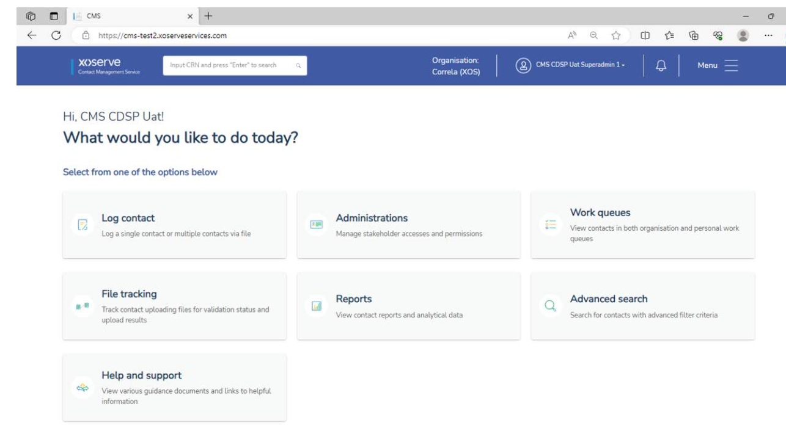
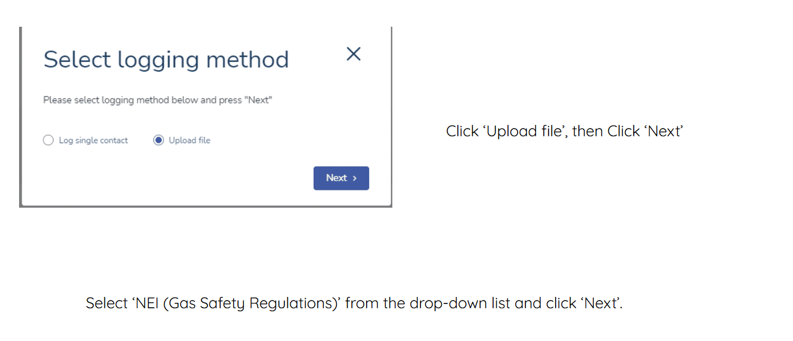

NEI file format

Detailed process information related to GSR process is covered within the e-learning training material available on Xoserve websites and can be found here.

​Where IGTs identify that the site has been successfully made Dead, IGTs can us the UK Link Portal to update the Supply Meter Point Status held within UK Link. ​​

*note the above training material will be updated to include IGTs as a listed stakeholder in the process.

Transportation Charges and invoicing​
Invoicing activities CDSP perform relating to MUS and GSR processes will be applicable for IGT sites. Any transportation (commodity / capacity) charges associated to impacted period will recover charges on behalf of DNs (not IGTs). ​

​For the avoidance of doubt, any direct charges associated to IGT activities remain out of scope of CDSP services, with IGTs performing their own invoicing services.

Process Reporting information
To facilitate the processes a set of reports (Excel spreadsheets) are sent to the IGT and shipper customers for both MUS and GSR processes managed by the CDSP. Ahead of this change going live, IGT customers will be asked to confirm who requires the reporting information to be supplied to them via email. Details of each report are listed below for completeness :
- Rpt_id_568_GSR_Supplementary_Data
Recipient – GT and IGT
Frequency – Adhoc
Data items – MPRN, MP STATUS CODE, CURRENT MSN, METER FITTED DATE, Registered/Not Registered

- Transporter_Gas_safety_Visit_reporting (MOD469S Transporter Gas Safety Report)
Recipient: Shipper and GT/IGT
Frequency: Monthly
Data Fields: IGT, LDZ, Shipper Short Code, Status, MPRN, AQ

- Rpt_id_1125_GSR Mod 0518 Full Report (Mod 0518 Full report)
Recipients - Shipper and GT/IGT report
Frequency - Monthly
Data Fields - LDZ IDENTIFIER, IGT IDENTIFIER, METER POINT REFERENCE, METER POINT STATUS, METER REMOVAL DATE, REMOVED METER SERIAL NUMBER, METER STATUS, METER LOCATION, METER LOCATION DESCRIPTION, METER LINK CODE, ACCESS INFORMATION, BUILDING NAME / NUMBER, PRINCIPAL STREET, DEPENDENT STREET, DEPENDENT LOCALITY, POST TOWN, COUNTY, POST CODE, SHIPPER SHORT CODE AT METER REMOVAL, SHIPPER NAME AT METER REMOVAL, SUPPLIER SHORT CODE AT METER REMOVAL, SUPPLIER NAME AT METER REMOVAL, METER POINT AQ

- MUS_343_PTS
Recipients - Shipper
Frequency - Monthly
Data Fields – MPRN, MPRN Creation Date, Pot Name, Sub Category Code, Responsible Shipper, CRN (MUS / GSR), Meter Point Status Code, Mp Location Description, Original Withdrawal Date, Isolation Date (Meter Removal Date), Building Number, Building Name, Delivery Point Alias, Sub Building Name, Principal Street, Dependant Street, Double Dpnd Local, Dpndnt Locality, Post Town, County, Post Code, LDZ Identifier, IGT, SSC (FOM), FOM CRN, FOM, Meter Serial Number, FOM Shipper Reference, MSN (C&D), Date of Work ( C&D ), SSC (Conf Attempt), CNF Reference (Conf Attempt), Conf Rejected Date (Conf Attempt), Conf Rejection, MSG Text (Conf Attempt), Siteworks SSC (service request), Shipper MPRN Creation, C&D Rejection, Confirmation Rejection, Service Request, Attempted Read Submission

- MUS_343_Shipper_Activity
Recipients - Shipper
Frequency - Monthly
Data Fields – MPRN, MPRN Creation Date, Pot Name, Sub Category Code, Responsible Shipper, CRN (MUS / GSR), Meter Point Status Code, Mp Location Description, Original Withdrawal Date, Isolation Date (Meter Removal Date), Building Number, Building Name, Delivery Point Alias, Sub Building Name, Principal Street, Dependant Street, Double Dpnd Local, Dpndnt Locality, Post Town, County, Post Code, LDZ Identifier, IGT, SSC (FOM), FOM CRN, FOM Meter Serial Number, FOM Shipper Reference, MSN (C&D), Date of Word ( C&D ), SSC (Conf Attempt), CNF Reference (Conf Attempt), Conf Rejected Date (Conf Attempt), Conf Rejection MSG Text (Conf Attempt), Siteworks SSC (service request), Shipper MPRN Creation, C&D Rejection, Confirmation Rejection, Service Request, Attempted Read Submission

- MUS_343_Legit_Unreg
Recipients - Shipper
Frequency - Monthly
Data Fields – MPRN, MPRN Creation Date, Pot Name, Sub Category Code, Responsible Shipper, CRN (MUS / GSR), Meter Point status Code, Mp Location Description, Original Withdrawal Date, Isolation Date (Meter Removal Date), Building Number, Building Name, Delivery Point Alias, Sub Building Name, Principal Street, Dependant Street, Double Dpnd Local, Dpndnt Locality, Post Town, County, Post Code, LDZ Identifier, IGT, SSC (FOM), FOM CRN, FOM Meter Serial Number, FOM Shipper Reference, MSN (C&D), Date of Work ( C&D ), SSC (Conf Attempt), CNF Reference (Conf Attempt), Conf Rejected Date (Conf Attempt), Conf Rejection MSG Text (Conf Attempt), Siteworks SSC (service request), Shipper MPRN Creation, C&D Rejection, Confirmation Rejection, Service Request, Attempted Read Submission, Date Moved in to Legit

- MUS_343_Orphaned_All
Recipients - Shipper
Frequency - Monthly
Data Fields – MPRN, MPRN Creation Date, Pot Name, Sub Category Code, Responsible Shipper, CRN (MUS / GSR), Meter Point Status Code, Mp Location Description, Original Withdrawal Date, Isolation Date (Meter Removal Date), Building Number, Building Name, Delivery Point Alias, Sub Building Name, Principal Street, Dependant Street, Double Dpnd Local, Dpndnt Locality, Post Town, County Post Code, LDZ Identifier, IGT, SSC (FOM), FOM CRN, FOM Meter Serial Number, FOM Shipper Reference, MSN (C&D), Date of Work (C&D), SSC (Conf Attempt), CNF Reference (Conf Attempt), Conf Rejected Date (Conf Attempt), Conf Rejection, MSG Text (Conf Attempt), Siteworks SSC (service request), Shipper MPRN Creation, C&D Rejection, Confirmation Rejection Service Request, Attempted Read Submission

- MUS_343_SSP_All
Recipients - Shipper
Frequency - Monthly
Data Fields - MPRN, MPRN Creation Date, Pot Name, Sub Category Code, Responsible Shipper, CRN (MUS / GSR), Meter Point Status Code, Mp Location Description, Original Withdrawal Date, Isolation Date (Meter Removal Date), Building Number, Building Name, Delivery Point Alias, Sub Building Name, Principal Street, Dependant Street, Double Dpnd Local, Dpndnt Locality, Post Town, County, Post Code, LDZ Identifier, IGT, SSC (FOM), FOM CRN, FOM Meter Serial Number, FOM Shipper Reference, MSN (C&D), Date of Work (C&D), SSC (Conf Attempt), CNF Reference (Conf Attempt), Conf Rejected Date (Conf Attempt), Conf Rejection, MSG Text (Conf Attempt), Siteworks SSC (service request), Shipper MPRN Creation, C&D Rejection, Confirmation Rejection, Service Request, Attempted Read Submission

- Shipperless & Unregistered Summary
Recipients - GT and IGT
Frequency - Monthly
Data Fields – Screenshot as below
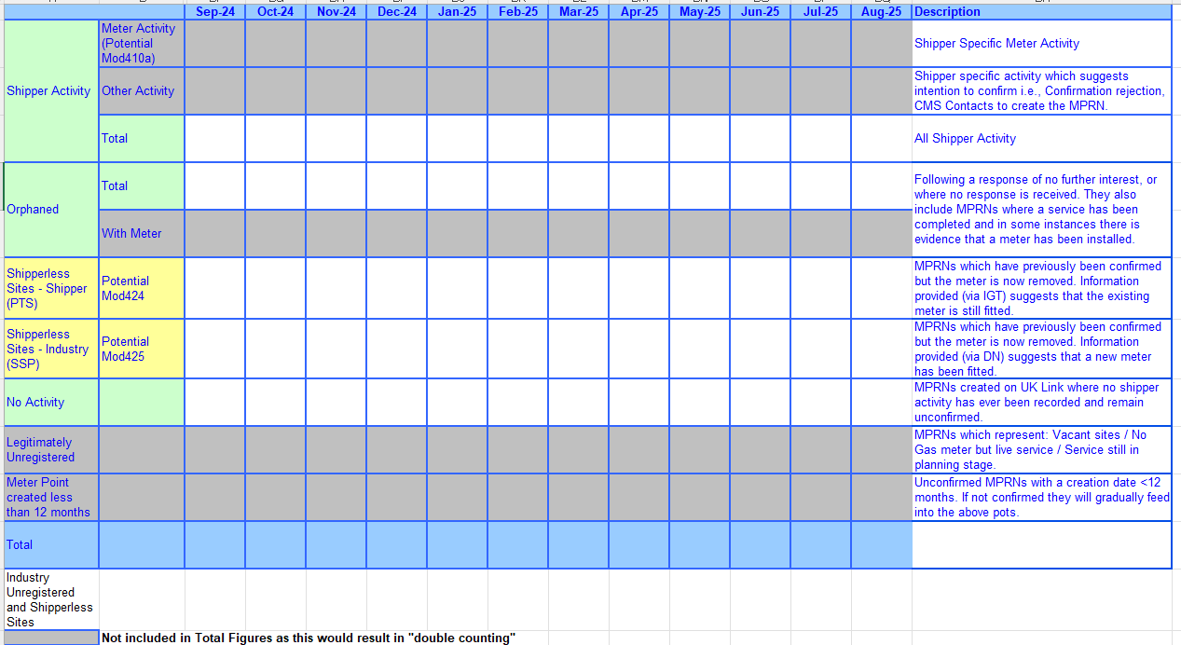

- [IGT]_Combined_Reports_MMM_YY
Recipients – GT and IGT
Frequency – Adhoc
Data Fields – Attached a sample format
IGT combined report

Further detail on the above information will be provided as part of XRN5732 Project training and onboarding activities that will be planned in with IGT stakeholders.

Associated Changes
Associated Change(s) and Title(s): | N/A

DSG
Target DSG Discussion Date: | 20th October 2025
Any further information:
Implementation
Target Release: | 5th December 2025
Status: | In delivery (Minor Release 15)

Industry Response Detailed design

«RangeStart:HDS»
Change Representation
(To be completed by User and returned for response)
Please consider any commercial impacts to your organisation that Xoserve need to be aware of when formulating your response

User Contact Details: | Organisation: | «h1_organisation»
 | Name: | «h1_name»
 | Email: | «h1_email»
 | Telephone: | «h1_telephone»
Customer decision on Change Pack: | «h1_userDataStatus»
Commercial impacts: | «h1_commercial_impacts»
Representation Publication: | «h1_consultation»
Representation Comments: | «h1_userDataComments»

Xoserve’ s Response
Xoserve Response to Organisations Comments: | «h1_xoserveResponse»

Please send the completed representation response to uklink@xoserve.com

«RangeEnd:HDS»

Version Control

Document
Version | Status | Date | Author(s) | Remarks
0.1 | Draft | 06.10.2025 | Nandini Kundu
1.0 | Approved | 10.10.2025 | Nandini Kundu

Template
Version | Status | Date | Author(s) | Remarks | Approved by
1.0 | Approved | 09/03/2022 | Rachel Taggart | Detail Design Change Pack transferred to own document | Change Management Committee on 09/03/2022
1.1 | Approved | 25/04/2023 | Rachel Taggart | Updated with new font branding | Emma Smith
1.2 | Updated | 14/08/2023 | Kate Lancaster | Updated with Representation tabs | N/A
1.3 | For Approval | 21/07/2025 | Kate Lancaster | Updated branding | To be approved by ChMC

