Detailed Design Change Pack

Communication detail
Comm Reference: | 3475.2 - VO - KG
Comm Title: | XRN5937.3 - Facilitating Bi-Directional Connections Between IGT pipelines and the NTS (Modification 0887) - Detailed Design Change Pack
Comm Date: | 18/05/2026

Change Representation
Action Required: | For Representation
Close Out Date: | 02/06/2026

Change Detail
Xoserve reference Number: | XRN5937.3
Change Class: | Functional
*ChMC Constituency Impacted | National Gas Transmission (NTS)  Shippers (all classes)  Independent Gas Transporters (iGT)
Change Owner: | Simon Harris  Service Manager (Gemini Services)  simon.harris@xoserve.com
Background and Context: | XRN5937.3 has been raised to deliver the requirements outlined in UNC Modification 0887.  UNC Modification 0887 has been raised to establish the commercial transportation arrangements applicable at bi-directional unmetered connections between IGT Pipelines and the NTS.  A number of developers, due to their geographical location, are looking at injecting new biomethane gas from anaerobic digester (AD) plants to potential IGT networks that would be connected to the NTS, potentially creating the requirement to flow from an IGT to the NTS. If there are additional connections to the IGT network that offtake gas, there is a potential for the connection to the NTS to be bi-directional in a scenario whereby demand from the IGT is greater than the supply of biomethane from the AD.  As the physical attributes of the connection to the NTS, are principally a bi-directional NTS connection to an independent Gas Transporter pipeline (IGT) that has no other connection to the Total System. A connection / concept of gas entering the NTS after entering an IGT network leaves the potential for double counting if the gas is treated as entering the GB network twice.  Under UNC Modification 0887 we are explicitly providing a bi-directional connection point on the NTS to an IGT pipeline. This sets out the commercial transportation arrangements that are applicable at such points:  - Point Definition  - NTS Access: NTS Entry and NTS Exit Capacity  - Measurement and Energy Balancing  - NGT Transportation Charges  At a high-level this Change Proposal is seeking to introduce a new bi-directional unmetered point type:  - Unmetered IGT NTS Connection point (comprising of an NTS System Entry and Exit Point on the NTS boundary).  - There will be corresponding Metered Entry and Exit Point/s on the IGT pipeline. The arrangement between the IGT and NTS will be covered within a Network Entry (Tri-partite) Agreement and the iGT Arrangements Document (iGTAD) of the UNC.

Change Impact Assessment Dashboard
Functional: | Gemini Screen Changes
Non-Functional: | Process and Documentation
Application: | Gemini, SAP BO/BW
User(s): | Gemini User Types GEME01 & GEME02, Gemini API Users, Shippers & Deloitte
Other: | n/a

Files
File | Parent Record | Record | Data Attribute | Hierarchy or Format Agreed
n/a | n/a | n/a | n/a | n/a

Change Design Description
To comply with the requirements under UNC Modification 0887 the CDSP are amending a number of services to enable customers to facilitate Bi-Directional Connections between IGT and NTS networks by utilising both an Exit and Entry for customers to register connection points and carry out appropriate activities against.

- Exit - Existing Meter Type [DC - Daily Metered Consumer]
- Entry - New Meter Type [IT - IGT Terminal]

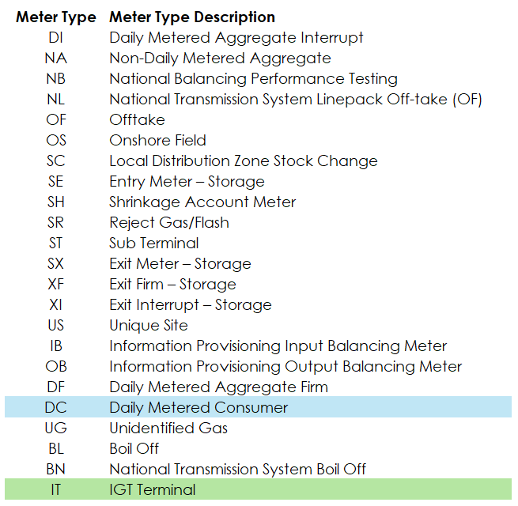

General Principle: Creating a new Meter Type within Gemini allows for activities to be carried out against connection points that are assigned to the selected Meter Type. Downstream processes remain unimpacted (unless specifically called out below) as these are mostly driven by other activity types / aggregation levels such as ASEP, activity numbers, billing zones, terminal IDs and locations etc. Meter Type ID is only visible and used when new connection points are created within Gemini Screens and therefore visibility to customers in downstream processes are minimal.

Gemini
For the Gemini system there are impacts to the following services (details of each are outlined later within this Change Pack):

- External Screens / Services
  - Meter
  - Nomination
  - Measurement
  - Allocation
- External Balancing APIs
  - Shipper Imbalance API
  - Shipper End of Day Noms (hour Bar) API
  - Shipper Preliminary Balance API
- Balancing Shipper Files (Bulk Download)
  - Nomination (NMI/NMO)
  - Measurement Pre Closeout (MEI/MEO)
  - Measurement Post Closeout (MNI/MNO)
  - Allocation (MTI/MTO)
- Invoicing
  - NTS Entry Capacity Invoice (NTE)
  - NTS Optional Capacity Invoice (NCI)
  - Energy Balancing Invoice (EBI)
  - Entry Commodity Invoice (ECO)
  - NTS Exit Capacity Invoice (NXC)

External Screens / Services
There are several Shipper facing Gemini screens, across multiple services (Meter, Nomination, Measurement & Allocation) that are to be amended to include / report the new Entry Meter Type [IT - IGT Terminal].

Details of the impacted screens where the data item [Entry Meter Type] is present and therefore will include the new value of [IT], including level of impact can be found in the below attached document.

Please note: A full screen pack and updated training material will be made available closer to implementation and confirmation of this will be sent via the uklink@xoserve.com, once the test phases have been completed and material available.

External Balancing APIs
There are several existing APIs that are impacted by the inclusion of a new Entry Meter Type [IT - IGT Terminal].

Shipper Imbalance API
Entry Meter Type value [IT] to be made available within the inbound requests customers can make.

Shipper End of Day Noms (hour Bar) API
Shipper Preliminary Balance API
These APIs do not have the data item Entry Meter Type within the inbound or response API so customers are not functionally impacted, but for awareness, data / transactions carried out on the Entry Meter Type [IT] will be provided within these APIs (as per BAU).

For the avoidance of doubt, there are no amendments to the structure or API specifications as a result of this change, just the new Entry Meter Type [IT - IGT Terminal] being configured to allow for Shippers to fetch data (as there are no defined allowable value list for Meter Type data item that may appear within the API (XML/JSON) specifications).

Balancing Shipper Files (Bulk Download)
There are several Bulk Download files for Shipper use that are impacted by the introduction of the new Entry Meter Type [IT]. However, this impact results in no amendments to the structure or file formats, just Shippers can include any [activity numbers] associated with Entry Meter Type [IT] within their inbound requests to retrieve the details in accordance with the response file.

Below are the Shipper Bulk Download files that will be configured to have Entry Meter Type [IT] available for Shippers to request data:
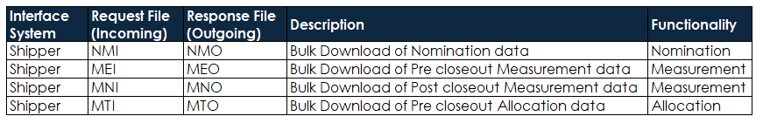

Invoicing
The following invoice processes are impacted by the introduction of the new Entry Meter Type [IT] by way of the associated Aggregated System Entry Point (ASEP) code being referenced in the invoice files.

For the avoidance of doubt, there are no file format changes related to the introduction of the new Entry Meter Type.

NTS Entry Capacity Invoice (NTE)
- The new ASEP Location will automatically flow into the charge calculation as per the ‘as is’ process.
- No NTE invoice file format changes will be required.
- Data field [ASEP] within the Entry Capacity invoice file will be populated with the new ASEP code created as part of MOD 0887 when there are eligible charges generated for applicable sites.

NTS Optional Capacity Invoice (NCI)
- No changes are required in the file processing or discount and Transmission Service charge calculation.
- Existing Eligible Quantity (EQ) calculation will consider the new Entry Meter Type [IT] in the calculations (to calculate Entry flow).
- The existing [DC] Exit Meter Type will be used in the EQ Calculation (to calculate Exit flow).
- Capacity relating to the new ASEP will be considered in the calculation of EQ values along with capacity of other existing ASEPs
- Capacity relating to the new NTS Exit point will be considered in the calculation of EQ values along with capacity of other existing NTS Exit points.
- No NCI invoice file format change will be required.

Energy Balancing Invoice (EBI)
- Entry Scheduling charge calculation will be modified to include the new Meter Type (IT) in the calculations.
- All other EBI charge calculations remain the same.
- No Energy Balancing Invoice file format change will be required.
- Data field ‘BILLING_ZONE’ within the Energy Balancing invoice file will be populated with the new Billing Zone created as part of MOD887 when there are eligible charges generated for MOD887 sites. BILLING_ZONE field is present under D10 and D11 record types within the invoice file.
- BILLING_ZONE - The particular entry zone for this charge.

Entry Commodity Invoice (ECO)
- Existing primary Commodity charge calculation job for the charge type (ECS) will be modified to include the new Meter Type [IT].
- Existing Adjusted Commodity Charge Calculation for the charge type (AES) will be modified to include the new Meter Type [IT].
- No Entry Commodity invoice file format change will be required.
- Following data fields within the Entry commodity invoice file will be populated with the new MOD887 values when there are eligible charges generated for them.
- TERMINAL_ID - Ten letter code that identifies the terminal
- TERMINAL_NAME_DESCRIPTION - Full Description name of the terminal

NTS Exit Capacity Invoice (NXC)
- New NTS Exit points will flow into the NXC charge calculations as per the ‘As Is’ process. No changes will be required.
- No Exit Capacity Invoice file format change will be needed.
- Data field ‘LOCATION’ within the Exit Capacity invoice file will be populated with the new Exit Location code created as part of MOD887 when there are eligible charges generated for MOD887 sites. The ‘LOCATION’ field is present across various record types within the invoice file.
- LOCATION - The Exit Location held within the Gemini Exit system which the charge item is in relation to.

Other
For non-Gemini System services, there are a number of internal reporting changes. However, as these are numerous, the full breakdown has not yet been completed and will be ratified during the testing phase of the project. If any external reporting is identified as being impacted by this change, these will be communicated at a later date in line with the Gemini Screen Pack & training updates.

Associated Changes
Associated Change(s) and Title(s): | UNC Modification 0887

DSG
Target DSG Discussion Date: | 26 May 2026
Any further information: | None

Implementation
Target Release: | AdHoc release - August 2026 (exact date to be confirmed and communicated out)
Status: | For Approval

Industry Response Detailed design

«RangeStart:HDS»
Change Representation

Please consider any commercial impacts to your organisation that Xoserve need to be aware of when formulating your response

User Contact Details: | Organisation: | «h1_organisation»
User Contact Details: | Name: | «h1_name»
User Contact Details: | Email: | «h1_email»
User Contact Details: | Telephone: | «h1_telephone»
Customer decision on Change Pack: | «h1_userDataStatus»
Commercial impacts: | «h1_commercial_impacts»
Representation Publication: | «h1_consultation»
Representation Comments: | «h1_userDataComments»

Xoserve’ s Response
Xoserve Response to Organisations Comments: : | «h1_xoserveResponse»

Please send the completed representation response to uklink@xoserve.com

«RangeEnd:HDS»

Version Control

Document
Version | Status | Date | Author(s) | Remarks
0.1 | Draft | 09/04/2026 | Simon Harris | Initial draft DDCPk
1.0 | Approved | 15/05/2026 | Simon Harris | Final approved DDCPk

Template
Version | Status | Date | Author(s) | Remarks | Approved by
1.0 | Approved | 09/03/2022 | Rachel Taggart | Detail Design Change Pack transferred to own document | Change Management Committee on 09/03/2022
1.1 | Approved | 25/04/2023 | Rachel Taggart | Updated with new font branding | Emma Smith
1.2 | Updated | 14/08/2023 | Kate Lancaster | Updated with Representation tabs | N/A
1.3 | For Approval | 21/07/2025 | Kate Lancaster | Updated branding | To be approved by ChMC

