High Level Solution Options Change Pack

Communication detail
Comm Reference: | 3441.1 - VO - KG
Comm Title: | XRN 5940 - Addition of Consumption Adjustment and Updated Meter Readings to initiate an AQ Calculation Month (Modification 0890)
Comm Date: | 17/11/2025

Change Representation
Action Required: | For Representation
Close Out Date: | 01/12/2025

Change Detail
Xoserve reference Number: | XRN 5940
*ChMC Constituency Impacted | Shippers, DNOs, IGTs
Change Owner: | Paul Orsler
Background and Context: | UNC Modification 0890 has been raised to allow the Annual Quantity (AQ) to be calculated when a valid Consumption Adjustments or Updated Meter Reading is received during the current AQ calculation period.  This Change Proposal has been raised to deliver the central system and corresponding DSC Service Changes required as set out within this Modification.  To accommodate the rules that have been agreed, CDSP is required to add valid consumption adjustment and valid updated meter readings as triggers that initiate an AQ Calculation or AQ Revision as applicable.  This change seeks to adopt consistent logic across CDSP systems and services, as this would enable data that is already being provided and validated by the CDSP to be used in downstream AQ processes.

Solution Options
Solution Option Summary: | To meet the requirements of this change, a single, automated UK Link solution has been identified.  This solution will amend the current AQ calculation functionality where necessary and introduce new functionality for revising AQ for new triggers (Consumption Adjustments and Updated Meter Reads), ensuring these triggers are recorded within the core system and ARE available for both AQ calculation and AQ revision purposes. Additionally, this solution will modify internal AQ tools and AQ reports that underpin CDSP’s existing service performance.  Given the nature of the services being modified and impacted by this change, delivery of this solution will need to ensure A high degree of emphasis is placed on performance and regression of the changes being implemented to ensure no impacts to the service are experienced by customers.  Following a through impact assessment on the solution option we have now determined that delivery costs and timescales are as follows;  Delivery cost: £160k to £270k  Delivery Timescales: 34 weeks + minimum 5 weeks of PIS  Based on these estimates, the earliest Major Release that could accommodate the changes to UK Link would be November 2026. An Alternative Adhoc delivery approach could see the related changes delivered in August 2026.  Key Information on XRN5940 Solution Option  The scope of the change intends to cater for all site types, for all Valid Accepted Updated Meter Readings for class 2,3 and 4 Supply Meter Points and, all valid accepted Consumption Adjustments for all Supply Point Classes - excluding any Consumption Adjustments with reasons ‘isolation’ and ‘duplicate’.  The solution does not intend to make any changes to the way in which Updated Meter Readings or Consumption Adjustments are supplied to CDSP, with these remaining as-is. Additionally, changes to AQ Correction and Winter Consumption calculation processes are not considered within scope of the solution.  Functionally, there are three main components of the automated UK Link solution that will need to be fully accommodated to meet the requirements of the change;  - Changes to monthly AQ calculation process to include replacement reads and consumption adjustments as triggers  Changes to the AQ Calculation process, to introduce primary and secondary triggers to be used in the AQ Calculation.  New functionality to support concept of AQ Revision being introduced int UK Link, which will enable secondary triggers to recalculate an appropriate AQ within the relevant metered period.  New validations to be performed to ensure only valid read replacements and Consumption Adjustments are used in AQ Revisions.  Introduction of new failure to calculate notification details to be supplied to Shippers for applicable AQ Revision scenarios.  - Changes to internal AQ tools and AQ reports  Ensure existing AQ Calculation tools and reports are changed to accommodate and include new AQ Calculation and AQ Revision triggers.  - Volume and performance of AQ Calculations  Extensive Performance and Regression testing to be performed to protect integrity of AQ Calculation process  A list of current assumptions that have been captured against the solution are detailed in the table below;  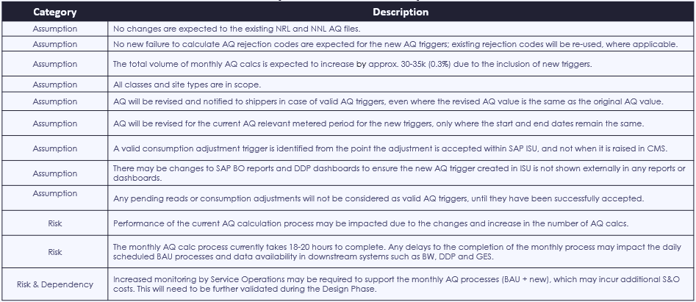  This information and further detail on the solution options, inclusive of scenarios that have been assessed to provide an overview of the solution logic, are available in the attached presentation.  To confirm, the above information will be discussed at the upcoming DSC Change Committee Delivery Sub Group meeting on Monday 24th November.
Proposed Implementation Date: | Tbc – Adhoc (August 2026) or Major Release (November 2026) – subject to design completion and delivery risk analysis being undertaken.
Xoserve preferred option:  (including rationale) | N/A
DSG preferred solution option:  (including rationale) | Monday 20th October 2025

Service Lines and Funding – for each option
Service Line(s) Impacted - New or existing | Existing  DS-CS-SA2-01 – updated to include additional Service Requirement Triggers within the DSC Service Description Table
Level of Impact: | N/A
Impacts on UK Link Manual/ Data Permissions Matrix | N/A

Industry Response Solution Options

«RangeStart:EDS»

Please consider any commercial impacts to your organisation that Xoserve need to be aware of when formulating your response

Organisation’s preferred solution option
User Contact Details: | Organisation: | «e1_organisation»
User Contact Details: | Name: | «e1_name»
User Contact Details: | Email: | «e1_email»
User Contact Details: | Telephone: | «e1_telephone»
Organisation’s preferred solution option, including rationale taking into account costs, risks, resource etc: | «e1_preferredSolutionOption»
Commercial impacts: | «e1_commercial_impacts»
Customer decision on preferred solution option: | «e1_dsgSolutionOption»
Publication of consultation response: | N/A

Xoserve’s response
Xoserve Response to Organisations Comments: | «e2_xoserveResponse»

«RangeEnd:EDS»

Version Control

Document
Version | Status | Date | Author(s) | Remarks
1.0 | For Representation | 13/10/25 | Paul Orsler | Issued for Consultation

Template
Version | Status | Date | Author(s) | Remarks | Approved by
1.0 | Approved | 09/03/2022 | Rachel Taggart | Initial Review Change Pack transferred to own document | Change Management Committee on 09/03/2022
1.1 | Approved | 25/04/2023 | Rachel Taggart | Updated with new font branding | Emma Smith
1.2 | Updated | 14/08/2023 | Kate Lancaster | Updated Representation tabs | N/A
1.3 | For Approval | 21/07/2025 | Kate Lancaster | Updated branding | To be approved by ChMC

